

DEPARTMENT OF MASTER OF COMPUTER APPLICATIONS

LABORATORY MANUAL

III Semester
Batch:2024-26

Name: _________________
USN: __________________

Course: Cloud Computing
Course code: 24MCASS3
Course Credits: 0 : 1: 2

___________________________________________________________________________
RAMAIAH INSTITUTE OF TECHNOLOGY
(Autonomous Institute, Affiliated to VTU)
Accredited by National Board of Accreditation & NAAC with 'A+' Grade, MSR Nagar, MSRIT Post, Bangalore-560054
www.msrit.edu
Table of Lab Programs
Sl. No. | Programs/Exercise/Topic.
1. | AWS Account Setup and Configuration. AWS Console Overview. Enable MFA. Create AWS budget alert.
2.
3.
4.
5.
6.
7.
8.
9.
10.
11.
12.
13.
14.
15.
16.
17.
18.
19.
20.
21.
22.
23.
24.
25.
26.
27.
Date: 8-10-2025
Exercise: AWS Account Setup and Configuration. AWS Console Overview. Enable MFA. Create AWS budget alert.

AWS Console overview / AWS Home page/ AWS Dash board
Widgets – default view/ Add or remove widgets - small panels on the dashboard showing metrics or shortcuts; users can add or remove them as needed.
Region – Specifies the geographical data center location where your AWS resources are deployed.
Services – A categorized list of all AWS offerings such as Compute, Storage, Database, etc.
Search bar – A quick-access bar to search and pin frequently used services for faster access.
pin the most used services to console by clicking on star next to the service name.

Enable MFA
Notes
- Make sure your phone is unlocked, Bluetooth is on, and it uses a screen lock (fingerprint/PIN).
Option 1: Add a Passkey for Easier Login
Step1: Go to Security Credentials
- Sign in to AWS console.
- Go to your username → Security credentials.
- Under Multi-factor authentication (MFA) click “Assign MFA device.”
- Choose “Passkeys and security keys” → Next.
- On the next screen choose “Phone or tablet”.
- AWS will show a browser pop-up asking to use a device.
  - Select your phone (or “Use another device” if it prompts).
- Look at your phone — you should get a “Use passkey” or biometric prompt.
- Approve using fingerprint or phone PIN.
- Back in AWS, click Finish. The passkey is now your MFA method.
Next time you sign in, just choose “Sign in with a passkey” → approve on phone.
Step 2: Test the Login
- Sign out of AWS.
- Go to the login page.
- Choose “Sign in with a passkey” → Select your phone.
- Approve the prompt on your phone — you should be signed in without any MFA codes.
Option 2: Authenticator App
This uses a 6-digit code from Google Authenticator / Authy / Microsoft Authenticator.
- In Security credentials, click “Assign MFA device.”
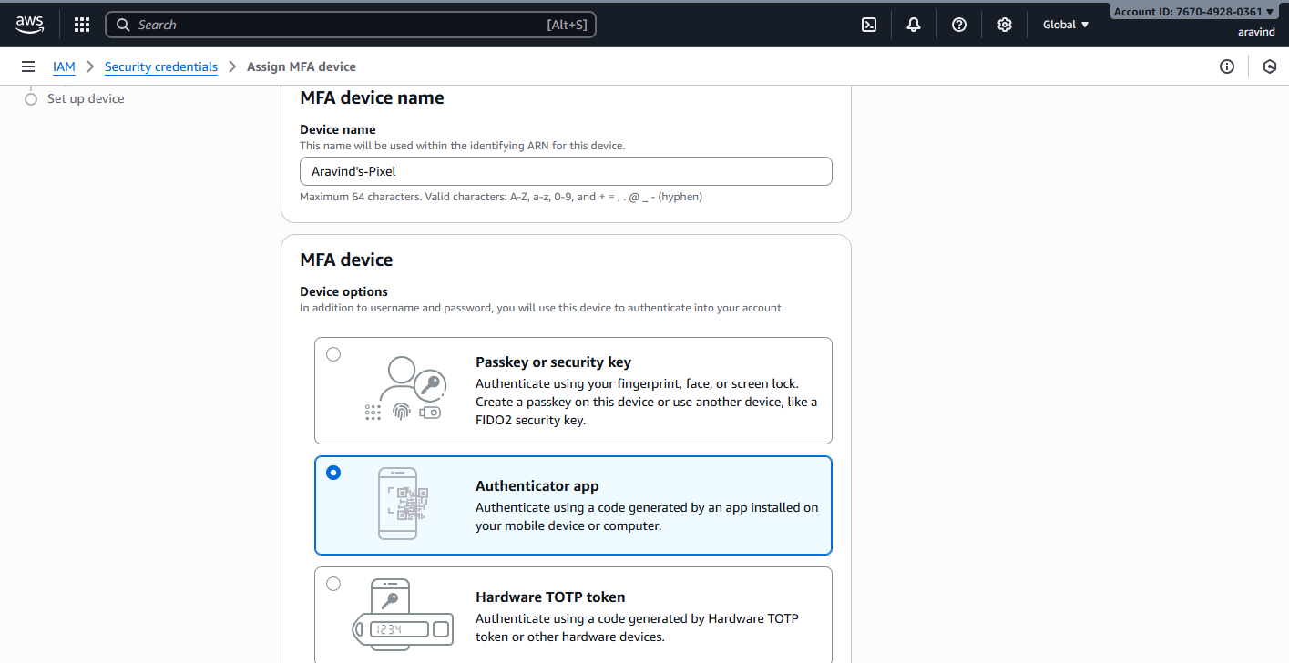

2.Select “Authenticator app” → Next.


3.A QR code appears.
4.Open your authenticator app on your phone → Add account → Scan QR code.
5.The app shows a 6-digit code.
6.Enter that code back in AWS → Assign MFA. You’ll use the 6-digit code from the app each time you log in.

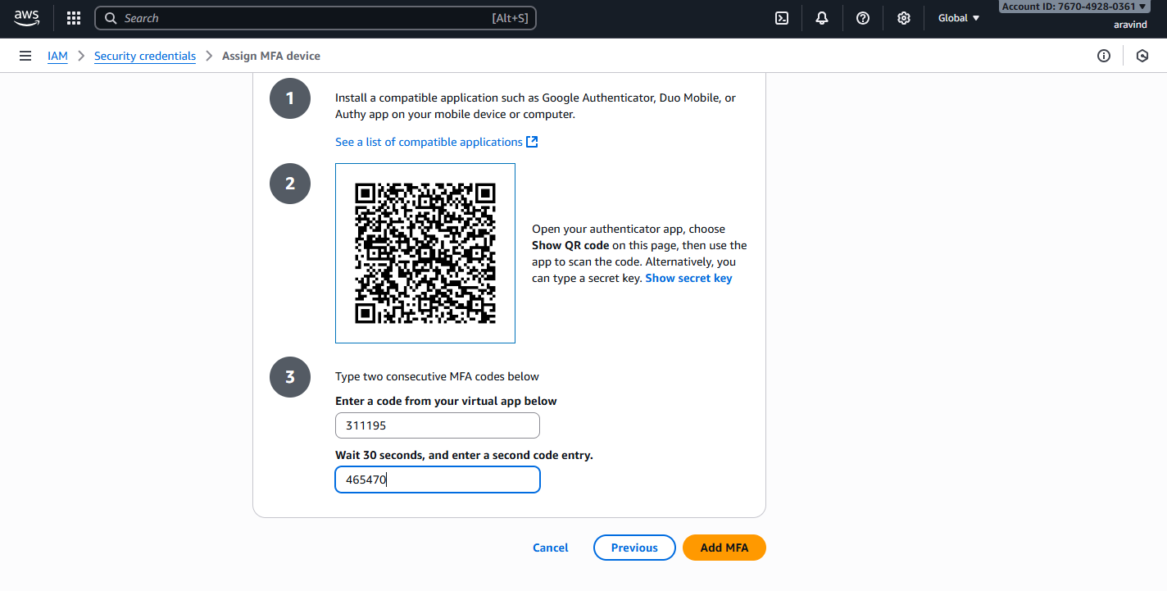
Create AWS budget alert
Allows to create a simple budget and to send alarms to registered email.
Example: if you are close to or exceeding your designated budget.
By setting a budget you can monitor budget threshold from the start.
Creating a budget
Step 1:
In the search bar type budgets and under the search results:
Select ‘Budgets’ from the Features group, which is essentially a feature of Billing and Cost Management service.
Step 2: After the ‘Budgets’ page loads
Click on Create Budget button
Under Budget setup select ‘Customize’ option
Under Budget types select ‘Cost budget’ option
Click on Next button.
Step 3: Set your budget page loads and fill in the details: MyBudget, Monthly, Recurring budget, set Month and Year, select Fixed – Budgeting method - Enter your budgeted amount – 20.00, select ‘All AWS services’ Scope options. Advanced options – leave it on default.
Click on Next button.
Step 4: Configure alerts
Click on Add an alert threshold
Under Set alert threshold
Set Threshold: 80 and Trigger: Actual
Email recipients: enter your email id.
Click on Next button.

Step 5: Under Attach actions – leave it on default
Click on Next button.
Step 6: In review page – check and review all the options are set to what is desired.
Click on Create budget button.
Now, the budget has been created.
Exercise:
Date: 9-10-2025
Exercise: AWS Identity Access Management (IAM) User and Group creation. Enable AWS IAM MFA. Create an AWS Account Alias (for Alternate Sign-in URL)

AWS Identity and Access Management (IAM) is a security service that helps you control who can access your AWS resources and what actions they can perform. It is a global AWS service.
It allows you to securely manage users, groups, roles, and permissions in your AWS account.
Concept | Description
Root User | The account owner who created the AWS account. Has full access and should be used only for account setup.
Group | A collection of IAM users that share the same permissions. For example, a “Developers” group or “Students” group.
User | A person or application that interacts with AWS (e.g., student1, admin, developer). Each user has its own username, password, and access keys.
Policy | A JSON document that defines what actions are allowed or denied (e.g., “allow S3 read access”).
Role | A set of permissions that can be temporarily assumed by a user, service, or application — often used by EC2 instances or Lambda functions.

STEPS for AWS IAM User Group Creation
Step 1: Sign in to AWS Console
- Log in to your AWS Management Console using an administrator account.
- From the Services menu, search for IAM and open it.
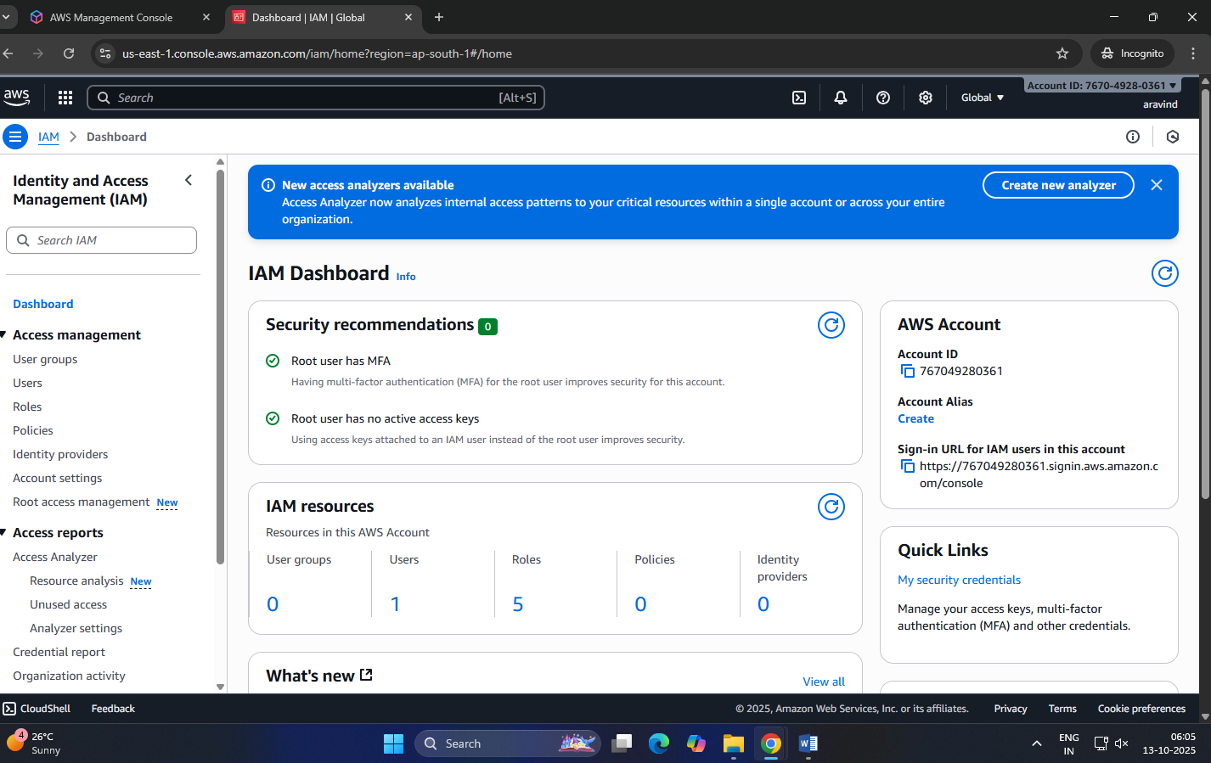

Step 2: Open Groups Section
- In the IAM dashboard, look at the left sidebar.
- Click on “User groups” → then click “Create group”.
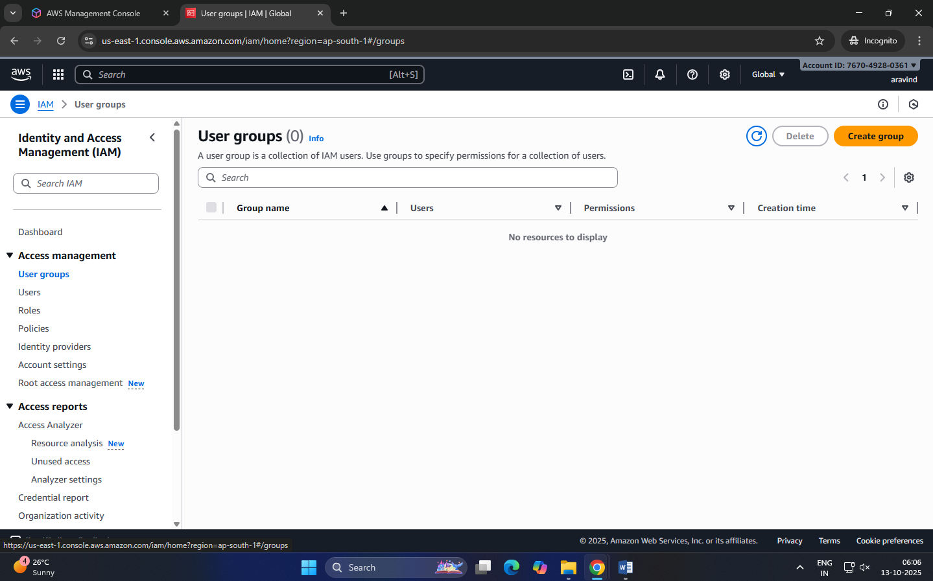
Step 3: Name the Group
- Enter a Group name (example: Developers, Admins, Students, etc.).
- Group names must be unique within your account.
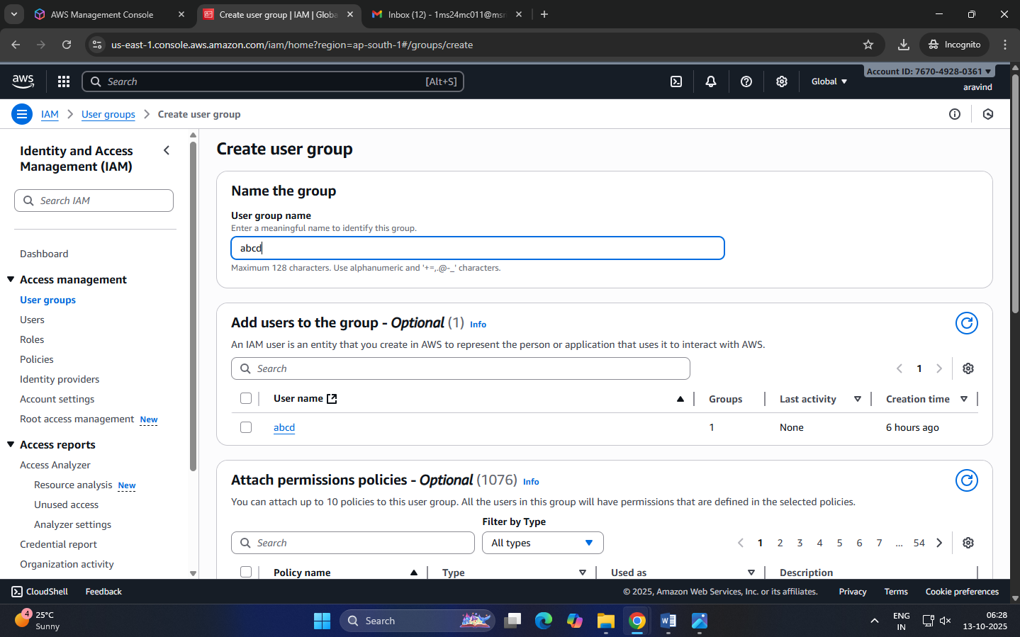
Step 4: Attach Permissions Policies
- You can attach IAM policies to define what members of the group can do.
Select the following:
  - AdministratorAccess → Full access to all services.
  - IAMUserChangePassword
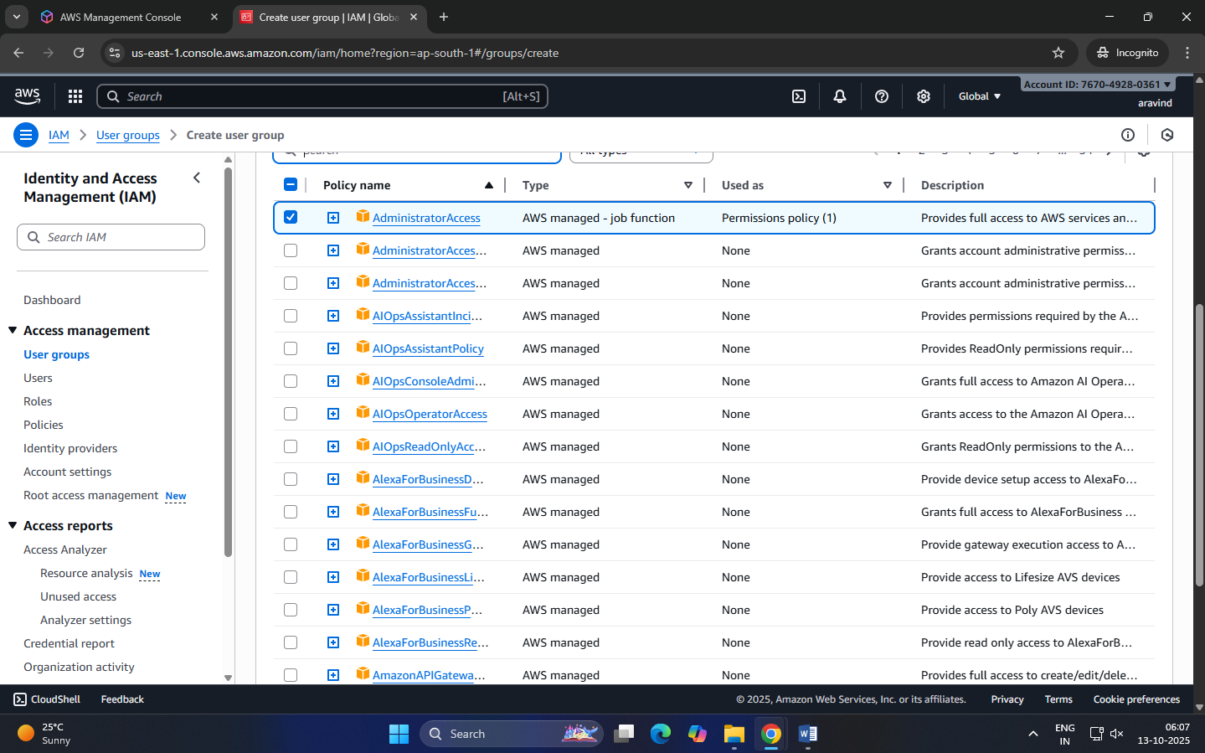
Step 5: Review and Create
- Review all details (group name + permissions).
- Click “Create group” to finalize.
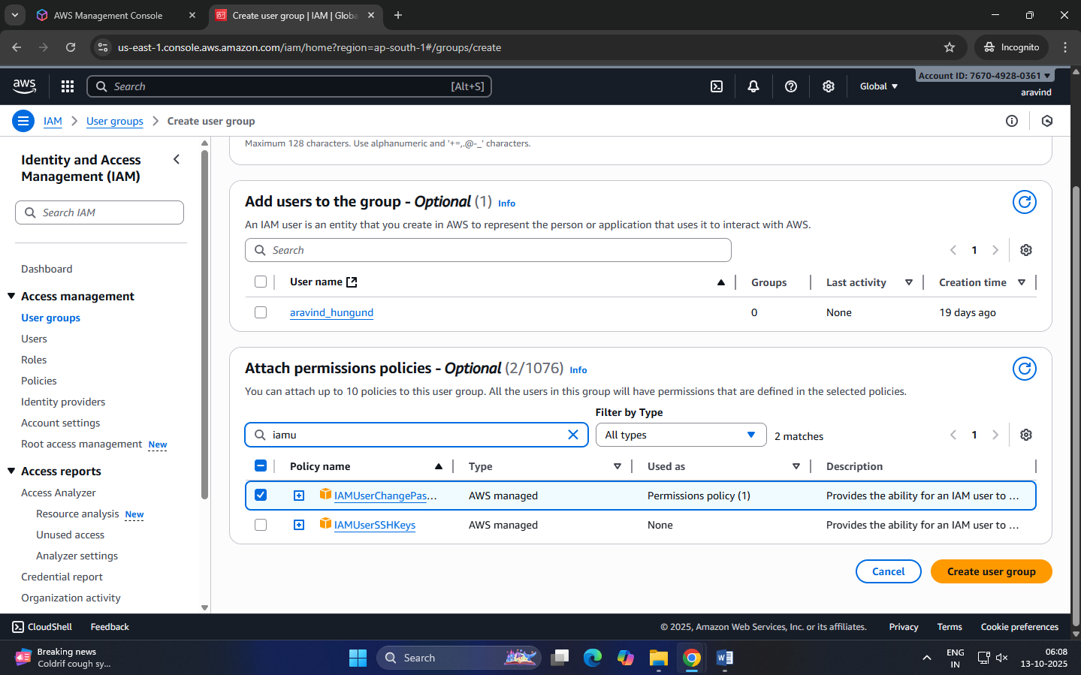
Group Successfully Created
- The new group now appears in the IAM dashboard.
- Any user added to this group automatically inherits all permissions attached to the group.
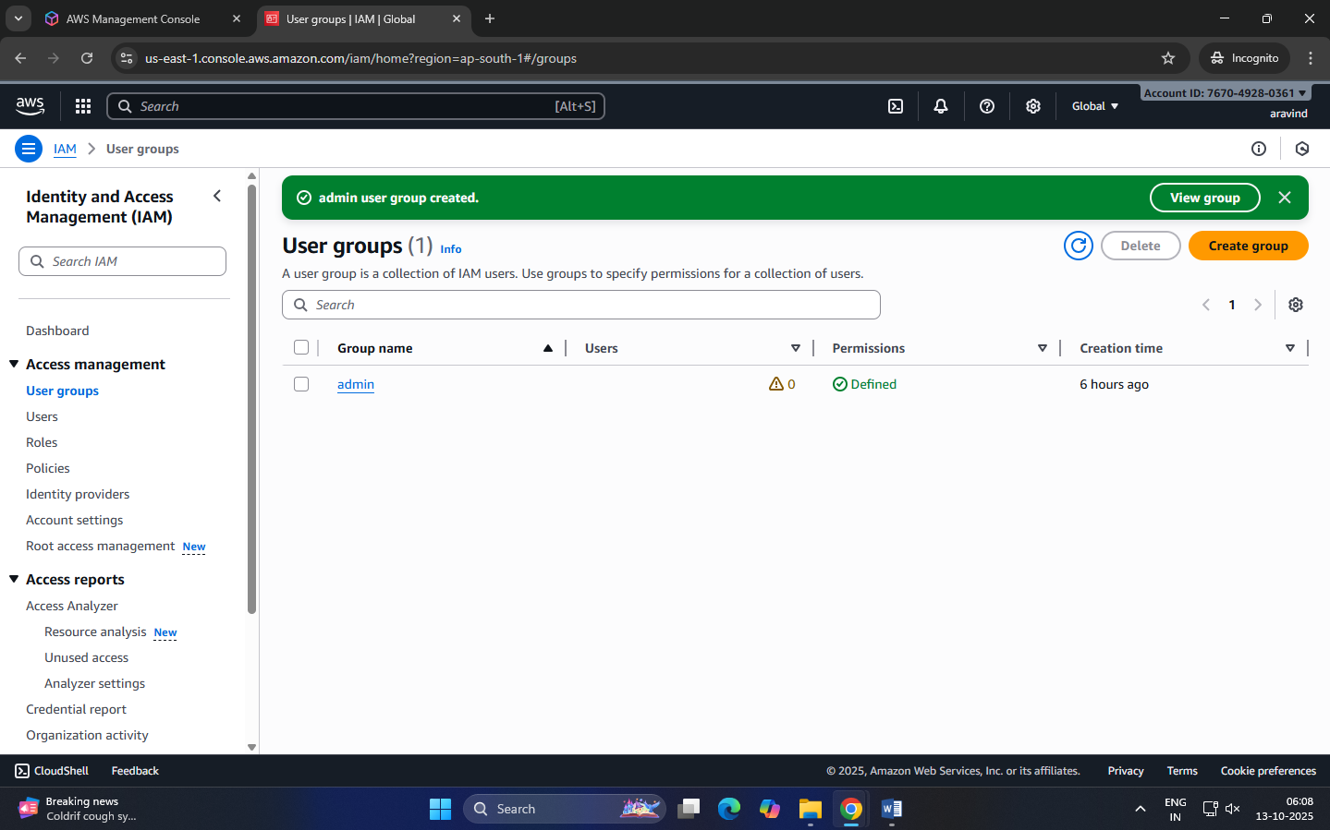

STEPS for AWS IAM User Creation
Step 1: Sign in to AWS Management Console
- Login to the AWS Management Console using your root user credentials.
- In the search bar, type IAM and open IAM service.
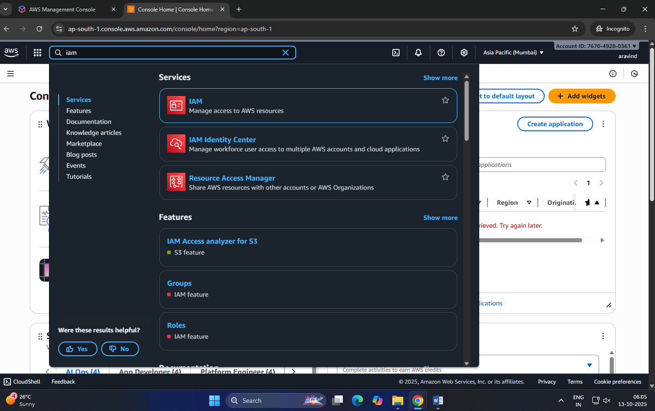

Step 2: Navigate to Users Section
- In the IAM dashboard’s left panel (info panel), click on Users.
- Then click on the “Add users” button.
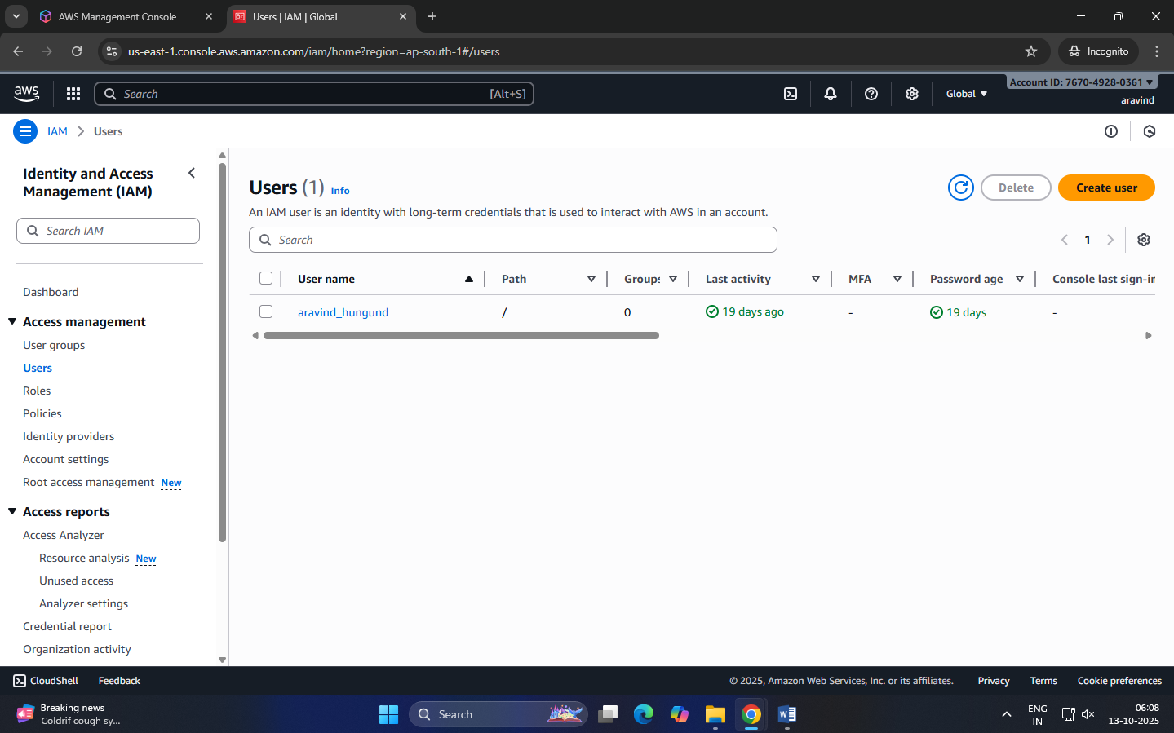

Step 3: Set User Details
- Enter a user name.
- Checkbox – ‘Provide user access to the AWS Management Console’.
- Select ‘I want to create an IAM user’ option
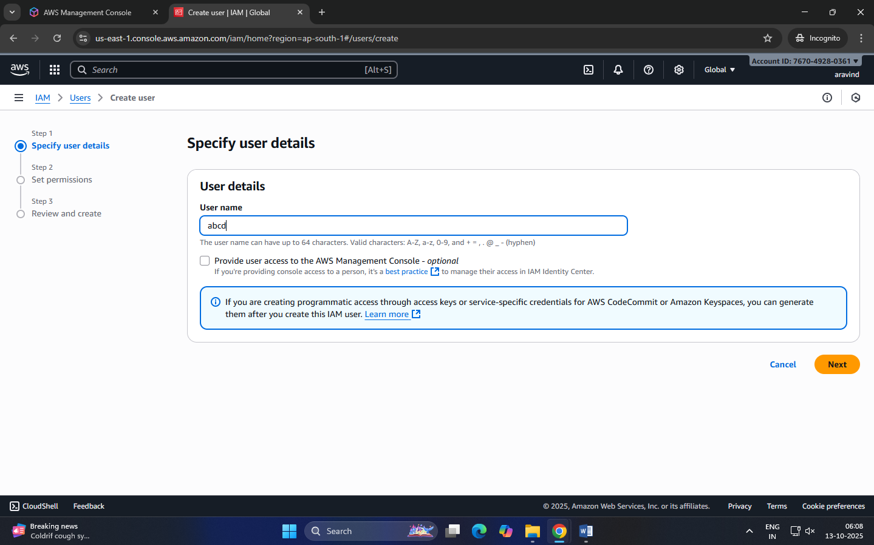
Step 4: Set Permissions
You can grant permissions to the new user in three ways:
- Add user to group – Assign predefined permission groups.
- Copy permissions from an existing user.
- Attach existing policies directly.
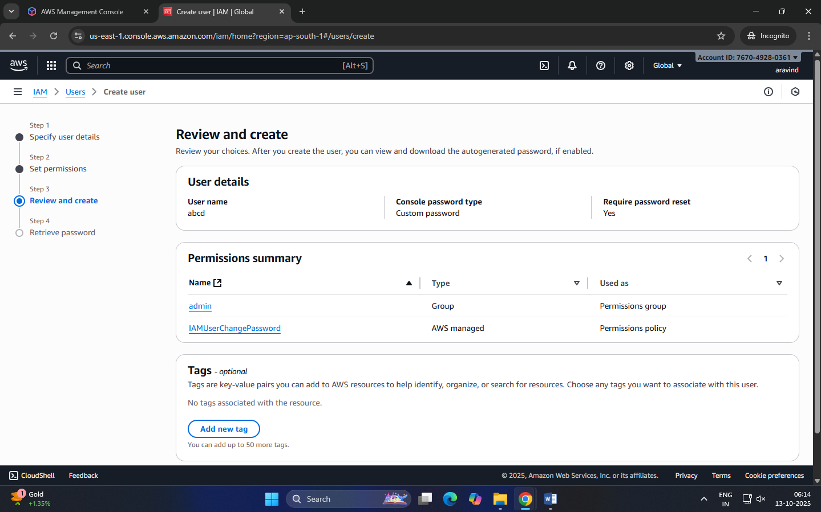
Recommended: Use IAM groups to manage permissions easily.
Step 5: Set User Details and Tags (Optional)
- Add tags like Department: MCA or Role: Faculty/Student for easy identification.
- Click Next to review.
Step 6: Review and Create User
- Review all settings (user name, permissions, tags).
- Click Create user.
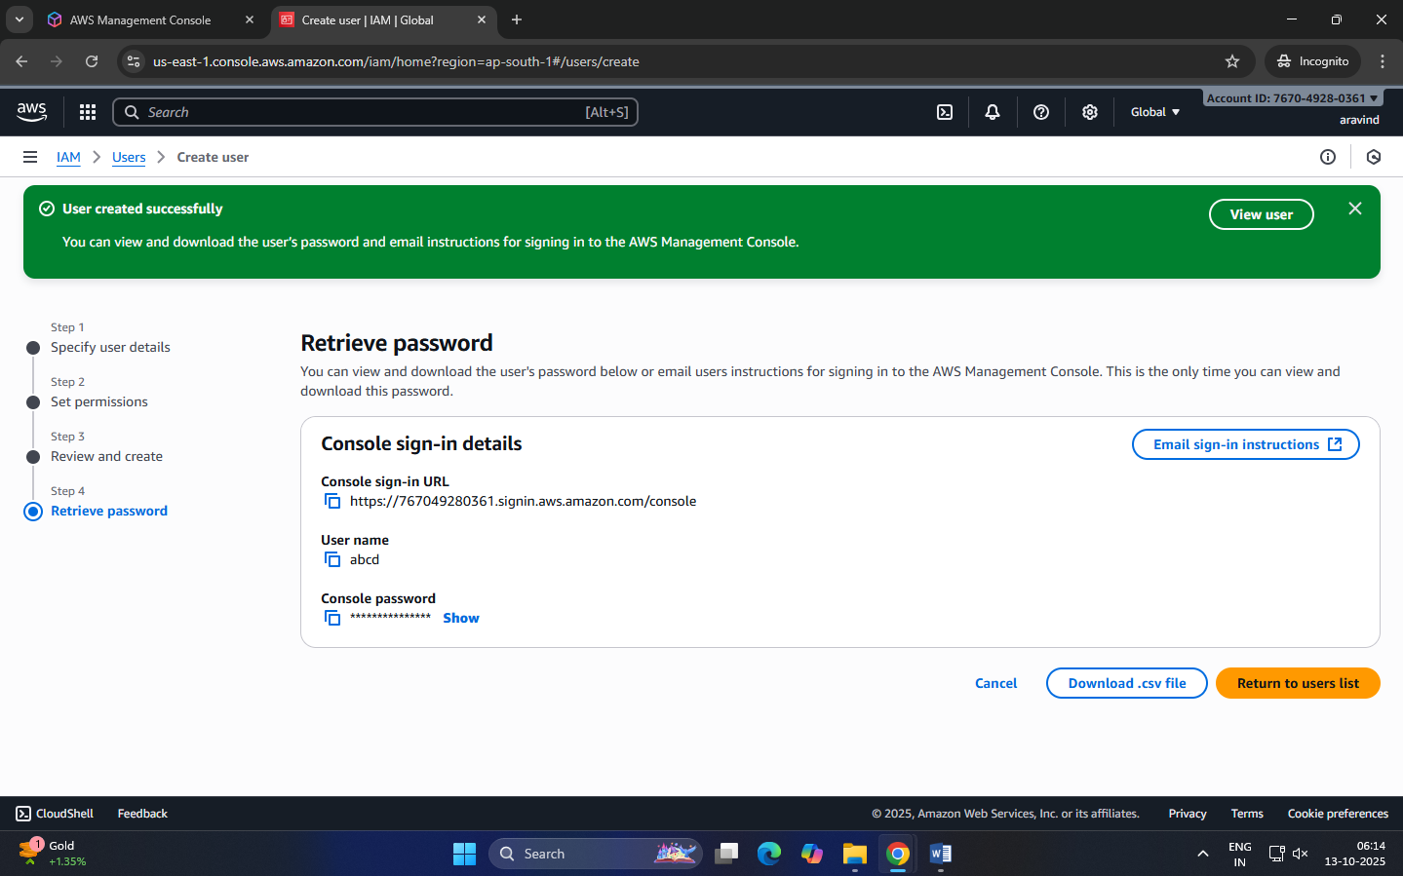
Step 7: Save Credentials
- After creation, AWS displays:
  - Console sign-in URL
  - Username
  - Password
NOTE: Download or copy these credentials immediately — they cannot be retrieved later.
Step 8: Test the User Login
- Visit the IAM login URL provided (unique for your AWS account).
- Log in with the newly created username and password.
- Verify access and permissions.

Enable AWS IAM MFA
Step 1: Sign in to AWS Console as root user
Step 2: Open IAM Dashboard
- In the search bar, type IAM and select IAM (Identity and Access Management).
- From the left navigation pane, select Users.
Step 3: Select a User
- Click the user name for whom you want to enable MFA.
- This opens the User Summary page.
Step 4: Go to Security Credentials Tab
- Click the Security credentials tab.
- Scroll down to the section “Multi-factor authentication (MFA)”.
Step 5: Assign MFA Device
- Click “Assign MFA device”.
- Choose the MFA type:
  - Virtual MFA device (e.g., Google Authenticator, Authy — most common)
  - Security key (hardware-based, e.g., YubiKey)
  - Authenticator app on phone
Step 6: Configure Virtual MFA
- If you select Virtual MFA device:
  - Open your Google Authenticator or Authy app on your phone.
  - Scan the QR code shown on the AWS screen.
  - The app starts generating 6-digit codes.
Step 7: Verify MFA
- Enter two consecutive codes from your app in the verification fields.
- Click “Assign MFA”.
Step 8: Confirm Setup
- You will see a green checkmark confirming MFA is successfully assigned.
- The user now requires MFA each time they sign in.

Create an AWS Account Alias (for Alternate Sign-in URL)
As an IAM user you can sign in using the default URL or create an account alias for it.
An Account Alias gives your AWS account a name instead of using the long numeric Account ID in your sign-in URL.
This makes it easier for IAM users to remember and log in.
Step 1:
- Sign in to the AWS Management Console using root user or an IAM user with administrative privileges.
- In the search bar, type IAM, and open the IAM service.

Step 2:
- In the left navigation pane, scroll down and select Dashboard.
Step 3:
- Under the “AWS Account” section, find “Account Alias”.
- Click on “Create” (or “Edit” if one already exists).
Step 4:
- In the pop-up box, enter your preferred alias name.
- Click “Create alias”.
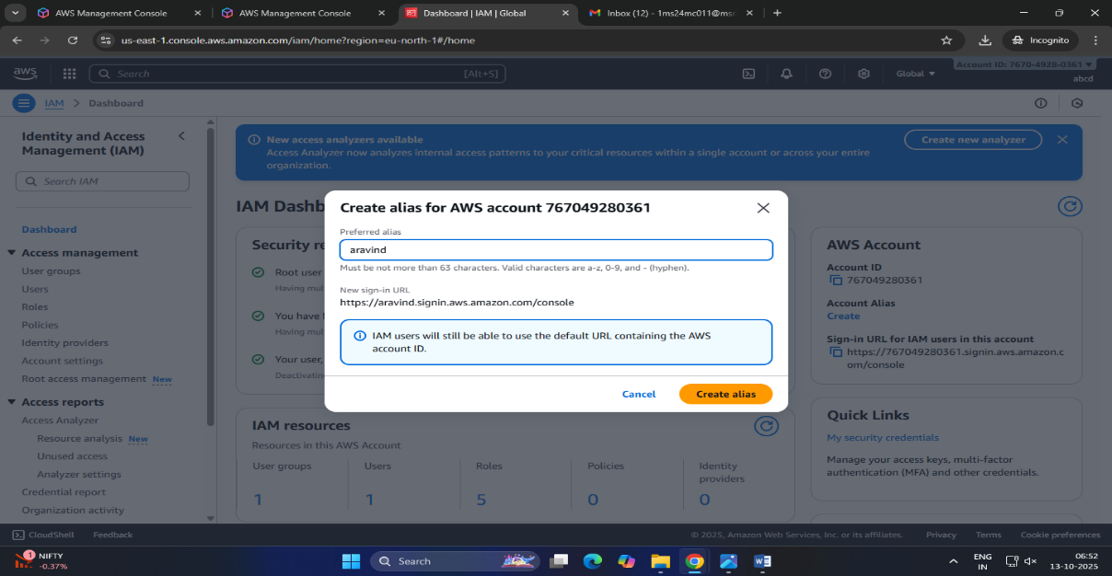
Step 5:
- Once created, you’ll see a new Sign-in URL displayed.
